ECE 3720

Microcomputer Interfacing Laboratory

Section 6

Timothy Driscoll

Date Performed: September / 12 / 2017

Lab 2

ABSTRACT:

A lab designed to show the application of a digital latch when combined with inputs from the PIC32MX150F128D microcontroller.

**INTRODUCTION:**

In this lab, we created a new project that combined software and hardware. The involved hardware included a 74LS373 D-Latch and a low active push button. The hardware components were combined with the software to create a project that displayed the values inputted by two DIO lines onto two LEDs. The D-Latch will then be setup to update when the button is pushed which will then display the results of the DIO lines on another set of two LEDs.

**EXPERIMENTAL PROCEDURES:**

In this lab, we started by unpacking the microcontroller and attaching the chip kit in the proper orientation to ensure that the pins wouldn’t have a flipped result. Then we could start wiring the circuit to complete the project. This circuit is represented by figure 1 below. The circuit includes the necessary hardware including the push button, latch and LEDs. A more detailed description of the pin connections can be found in the discussion section. After the completion of the circuit wiring, we created a new project using the MPLAB X IDE software. After creating the project, we added a new C type source file where we wrote the code in order to have the microcontroller function properly. The code can be viewed below in the figures and tables section. The flow of the code includes setting the proper pins as inputs and outputs, then setting the outputs equal to the inputs. The program could then be loaded to the microcontroller and the circuit could be tested using the NI-ELVIS Board and software.

**RESULTS and DISCUSSION:**

In this lab, we were successfully able to get the desired output from the project and achieve all the desired goals described in the slides. To start we successfully were able to take two inputs from the DIO (NI-ELVIS) and send them to the microcontroller. Then using the code, we assigned the DIO inputs stored in registers C05 and C03 to output registers B09 and C06. To prove that our code functioned correctly we set LED 1 and LED 2 to equal both of those output pins instead of connecting the DIO 1 and 2 directly to the LEDs. These two outputs from the microcontroller were also sent into the D-Latch. The next goal of the project was to have to D-latch update LEDs 3 and 4 when a button in the circuit was pushed. In order to complete this task, the button inputted a value into the microcontroller. The button produced a 0 when it was pressed because it was a low active push button. This input was then inverted by the code and assigned to output register C04 as seen in line 20 of the code. The output from C04 then went to the latch enable pin on the D-Latch, when the D-Latch received a 1 it would update the two output pins going to LEDs 3 and 4. In short once the button was pushed LEDs 3 and 4 would be updated to match LEDs 1 and 2. In this lab one error that I ran into which prevented me from getting the correct results in the beginning was in how I wired the button. I had it so the button was always being grounded and not producing the desired output when pressed. This issue was able to be troubleshooted after tracing some of the wiring back to the button.

**CONCLUSSION:**

We have come to the conclusion that in this lab there were some key procedural points that needed to be learned in order to achieve all the goals. To start we first needed to learn how to assign the specific registers to be output or input registers in the code. This allowed us to accept the DIO 1,2 and push button as inputs and set the D-Latch enable and data inputs as outputs. The next key point that needed to be understood was that the button was low active resulting in it to input a 0 to the microcontroller when it was pressed. We needed the push of the button to represent a 1 so we learned that we needed to invert the value before assigning it to the latch output. After determining this we needed to gain an understanding of the D-Latch to determine why the different LEDs would update when they did. I learned that in our circuit the outputs would be updated to equal their respective data inputs once a one was passed into the latch enable pin. The one into the latch enable pin came from the inverted push button input. Another piece of the code I needed to learn was why the infinite while loop was necessary in the code. The while loop is needed because while the microcontroller is being powered, we constantly want it to be updating the outputs. By working through the lab, I was able to determine all the necessary procedural points to understand and achieve the desired outputs for the lab.

**REFERENCES:**

Clemson University’s ECE 372 Lab 1 PowerPoint.

**FIGURES AND TABLES:**

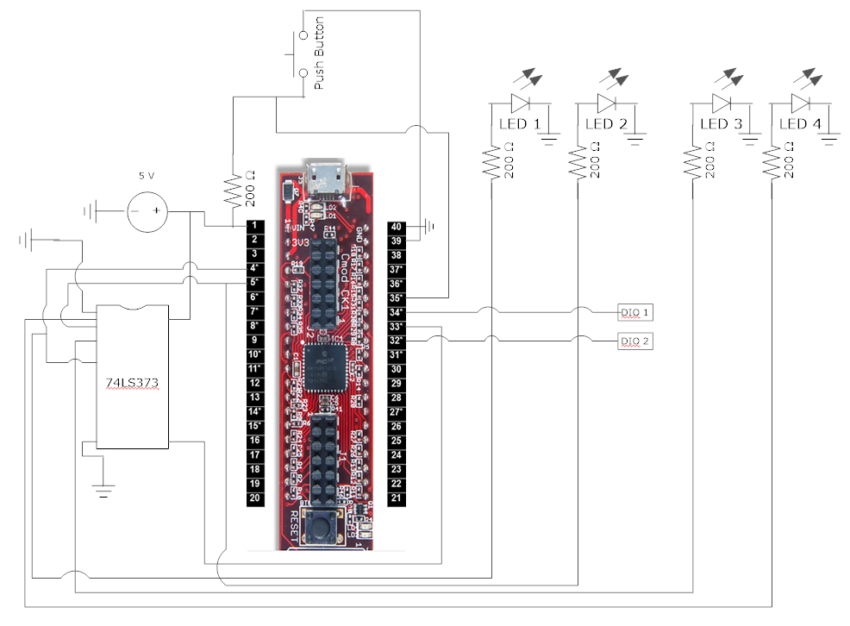

**Figure 1: Wiring for lab 2 (Pin connections described in experimental procedures)**

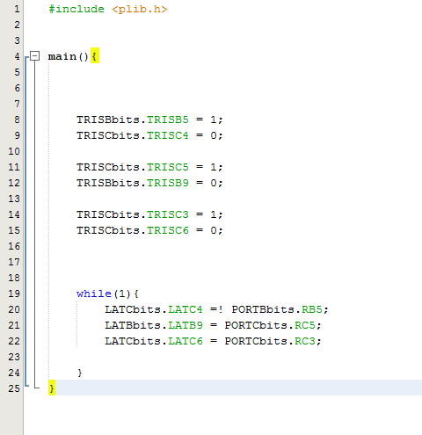**CODE:**